The CocktailDB API Automation

Contents

Project Overview 2

Prerequisites 2

Installation instructions 3

➢ GitHub Repository 3

➢ Project Setup and execution 5

Project Details 8

Contact information 8

|  |  |  |  |
| --- | --- | --- | --- |
| **Version** | **Date** | **Author** | **Description** |
| **0.1** | **2021-11-07** | **Shreya uttarwar** | **initail draft version** |
| **1** | **2021-11-18** | **shreya uttarwar** | **finalised document** |
|  |  |  |  |

# **Project Overview**

**The project consists of automation of API for TheCocktailDB API**

**It has been created for Derivco** **between 05-11-2021 and 08-11-2021. Technologies used to create the project are**

* **POSTMAN**
* **JavaScript/Postman scripting**

# **Prerequisites**

**Below are the prerequisites for configuration of the project**

* **POSTMAN**

# **Installation instructions**

## **GitHub Repository**

1. To access project source code, go to below link:

<https://github.com/uttarwarshreya/>[TheCocktailDB-API_Automation](https://github.com/uttarwarshreya/TheCocktailDB-API_Automation)

1. Click on fork and it should create a forked repository for logged in Git user.
2. Click on Code button and copy the repository path

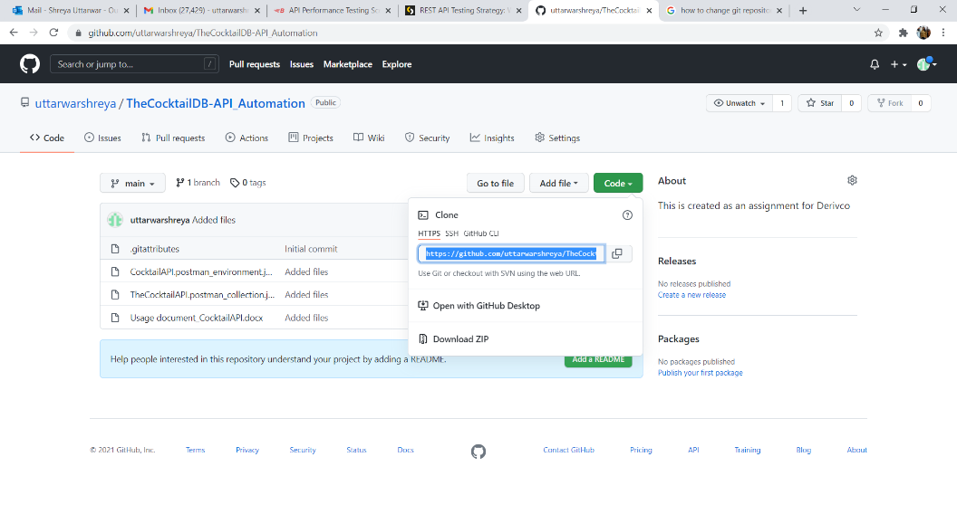

1. Open GitHub desktop and select clone repository from file menu

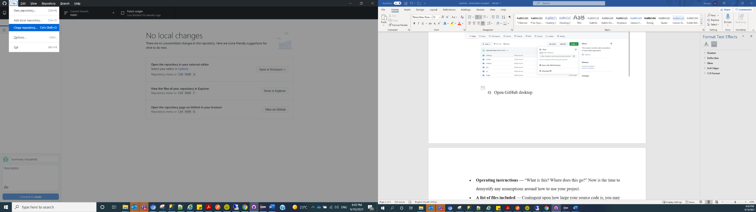

1. **Under URL tab enter copied URL in Repository URL textbox and select local path where you want to save the repository locally on your machine. Click on Clone button**

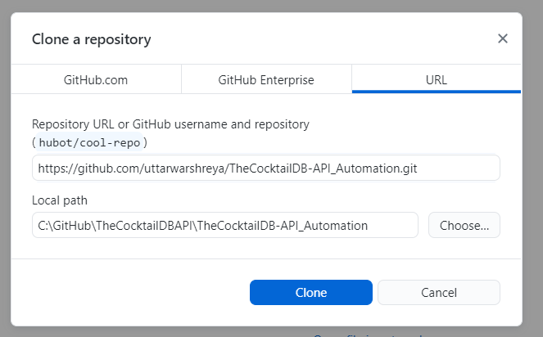

1. **Repository should be created on your local machine**

**Project Setup and execution**

1. **Open Postman application**
2. **Click on Import button and select the path of the project where repository is cloned in local machine.**

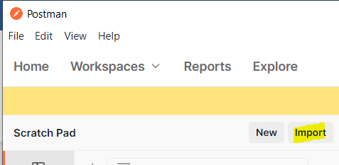

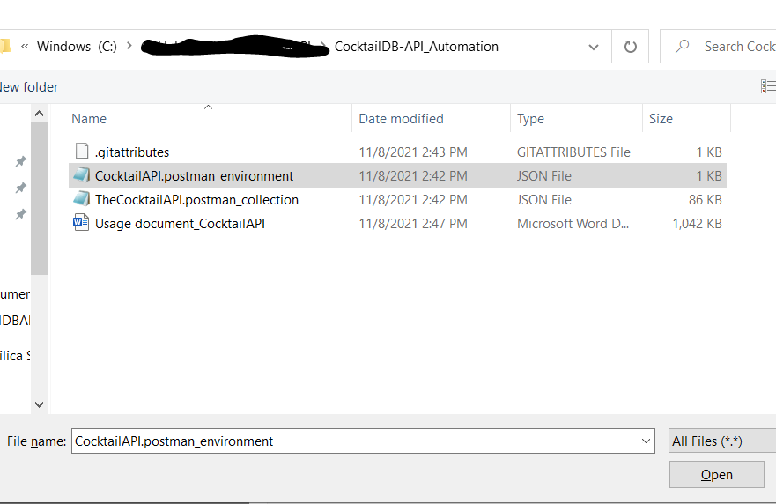

1. **Import both the files**

* **CocktailAPI.postman_environment**
* **TheCocktailAPI.postman_collection**

1. **Once imported below project should be displayed**

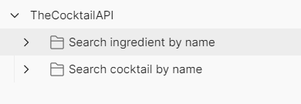

1. **Click on project and select run**

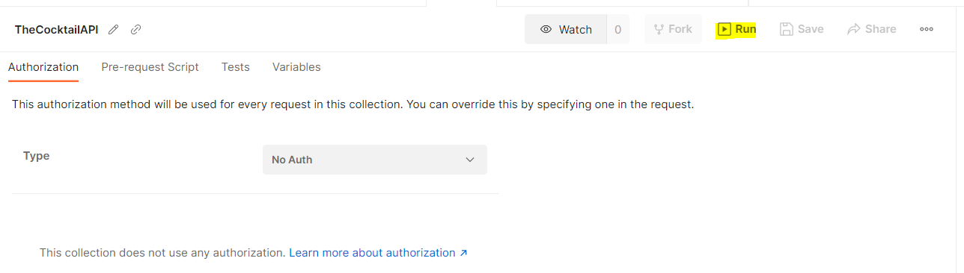

1. **Select ‘Run TheCocktailAPI’ once runner file is opened. This will execute all the test cases.**

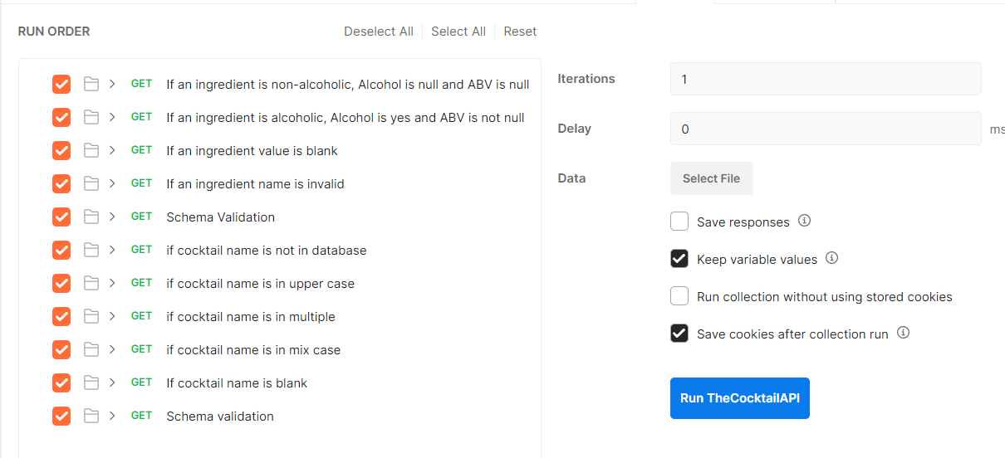

1. **Once execution is completed execution summary is displayed as below**

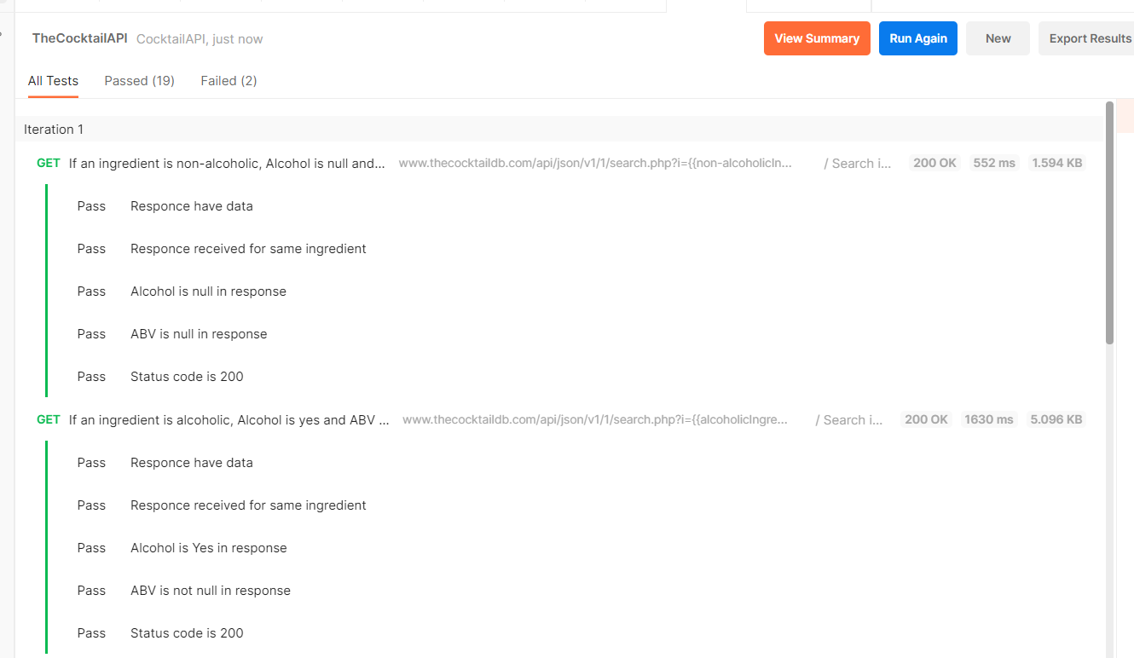

# **Project Details**

* **This project as been created to test the cocktaildb API using POSTMAN. It covers test scenarios mentioned the requirement document with few extra testcases.**

# **Contact information**

* Name : Shreya Uttarwar
* Email : [uttarwarshreya@gmail.com](mailto:uttarwarshreya@gmail.com)
* Mobile : 0847304410
* LinkedIn : <https://www.linkedin.com/in/shreya-uttarwar-62b80161/>